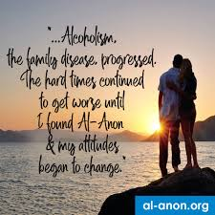

Dear ______________,

Thank you for your recent airing of the Al-Anon Public Service Announcement (PSA). While problem drinkers affect one in four people in our community, many people are still uninformed about
Al-Anon. Al-Anon groups are free service to friends and families who suffer from a loved one’s drinking. Members offer their experience, strength and hope to others.

Thank you for helping us reach the people who need help in our community.

Sincerely,

Grateful Al-Anon members
(Please have all members of your group, district, area sign and write a short note on this letter)

