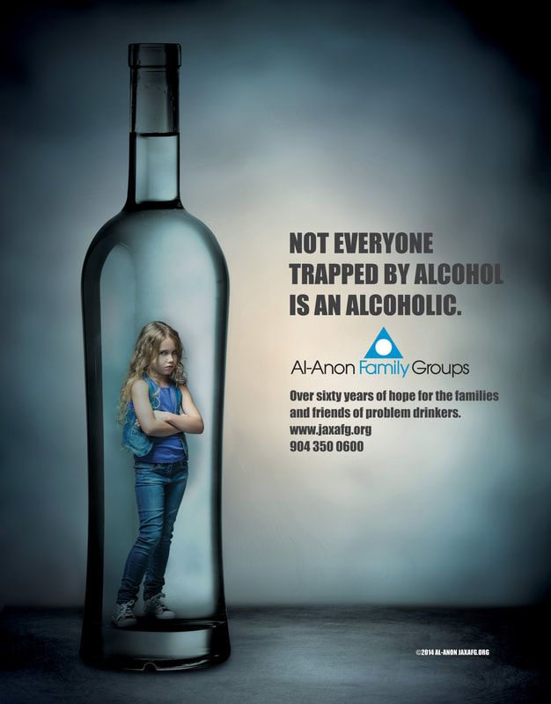

Not Everyone Trapped by Alcohol is an Alcoholic

Al-Anon supports family members and friends
who do not know how to cope with someone else’s drinking.

Greetings!
According to our records your station recently received the Al-Anon Public Service Announcements (PSA). We, the grateful current members of Al-Anon, want to encourage you to broadcast this Al-Anon PSA frequently.

Problem drinkers affect as many as one in four people in our community. However, many people are still uninformed about Al-Anon Family Groups’ and their free service to friends and families who suffer from a loved one’s drinking.

If you have received the PSA, please consider scheduling frequent broadcasts. If you have been playing the PSA, we thank you! If you have not received the Al-Anon PSA and would like to receive it, please contact PO@maineafg.org and make your request.

Thank you for your consideration and service to our community!
(Please have all members of your group, district or area sign this letter.)

